Reportofthevoluntarybloodcum Awarenessprogramme

The National Service Scheme unit Mawsynram Border Area College, Mawsynram in collaboration with Red Ribbon Cross(RRC) organized a one day Blood Donation camp cum Awareness programme on the 25th of November 2021 at the College premise at 11:30 am
- The Programme was hosted by Ms. Lawandeilang Sun Programme officer of NSS unit
- Dr.C.Budnah gave a brief introduction about Voluntary Blood Donation.
Mrs. Ariva M.Laloo highlighted the objectives of blood donation, types of bloods, sources of blood, facts about blood transfusion practice and elimination of professional Blood donor, etc.
- Avote of thanks was delivered by sir. C.T Dohtdong.
▸ The Blood Donation camp started at 12 O'clock.
- There were about 161 Participant/ Volunteers who volunteered for blood donation including the principal of the college.
- Out of 161 volunteers Only 5 participants are eligible to donate blood

- The programme concluded with a group photo and light refreshments. Note: photo attached here.
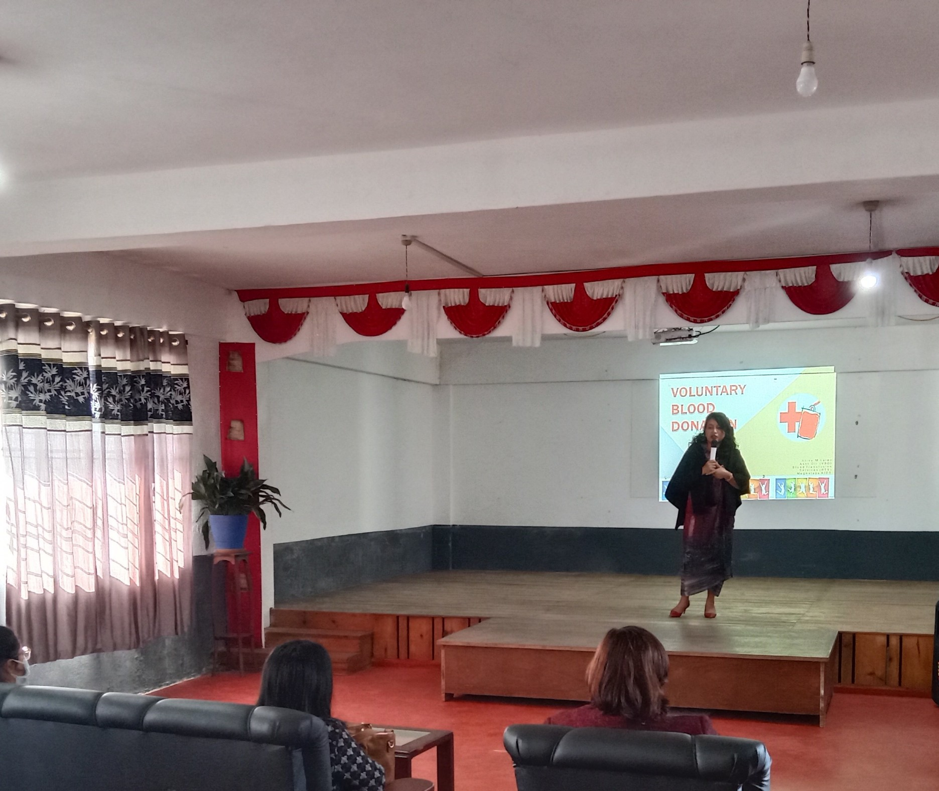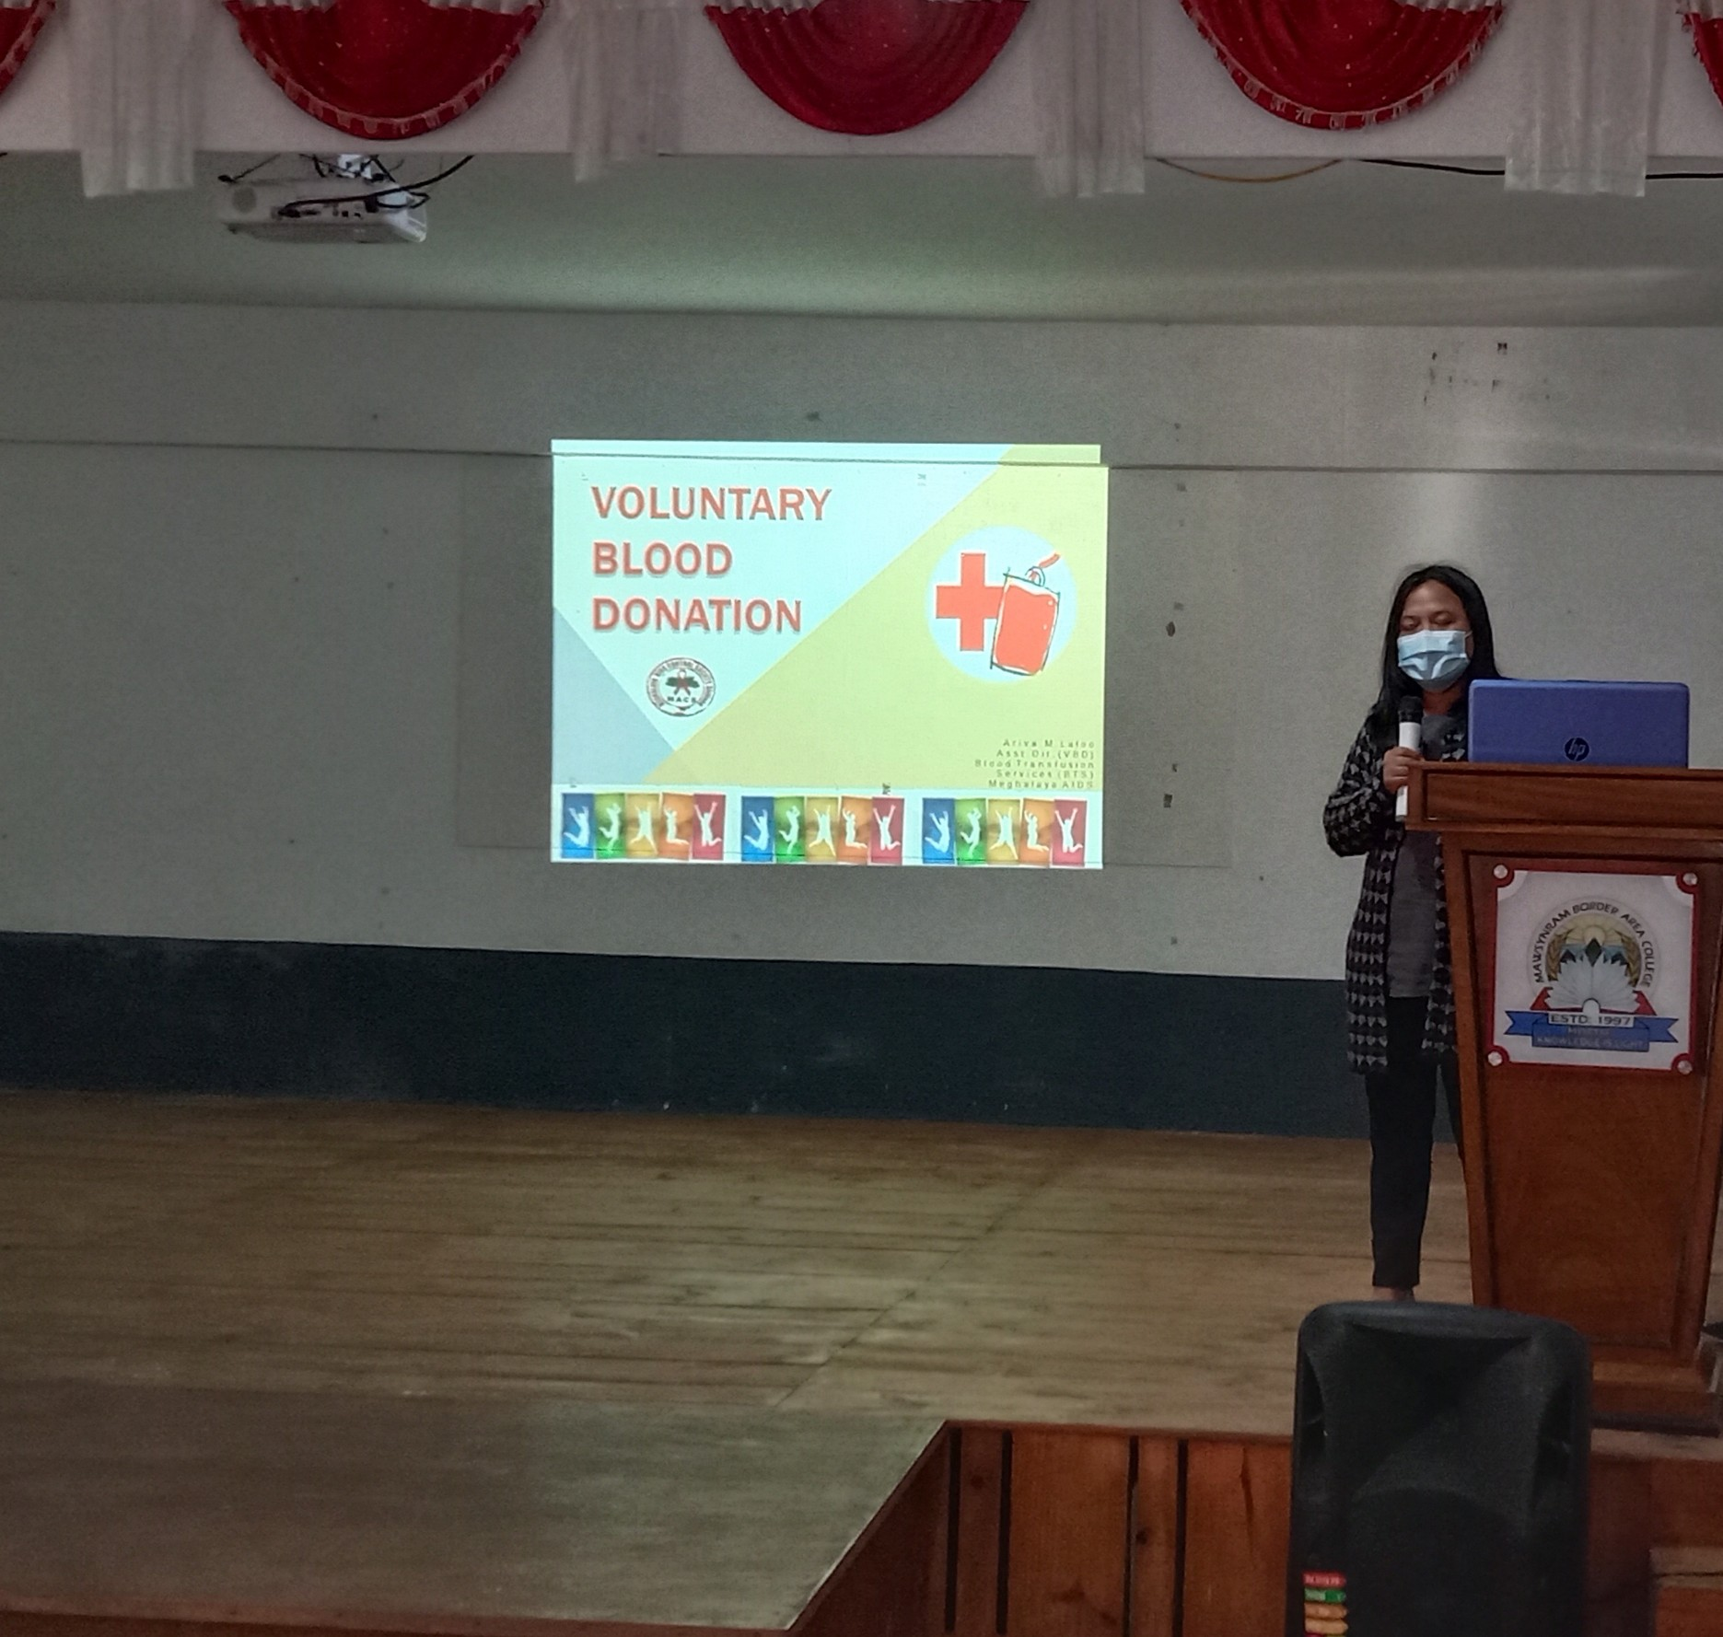

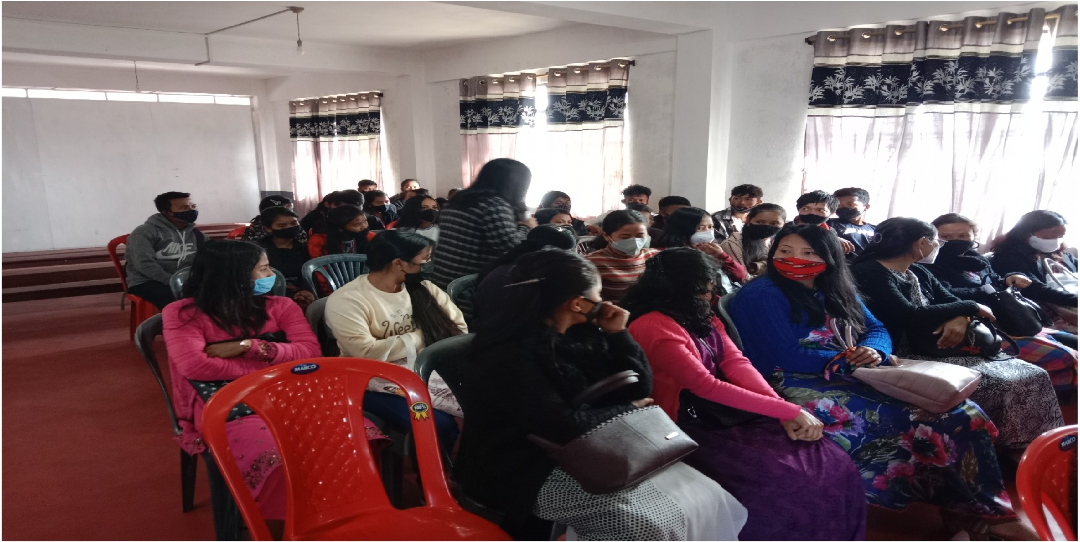

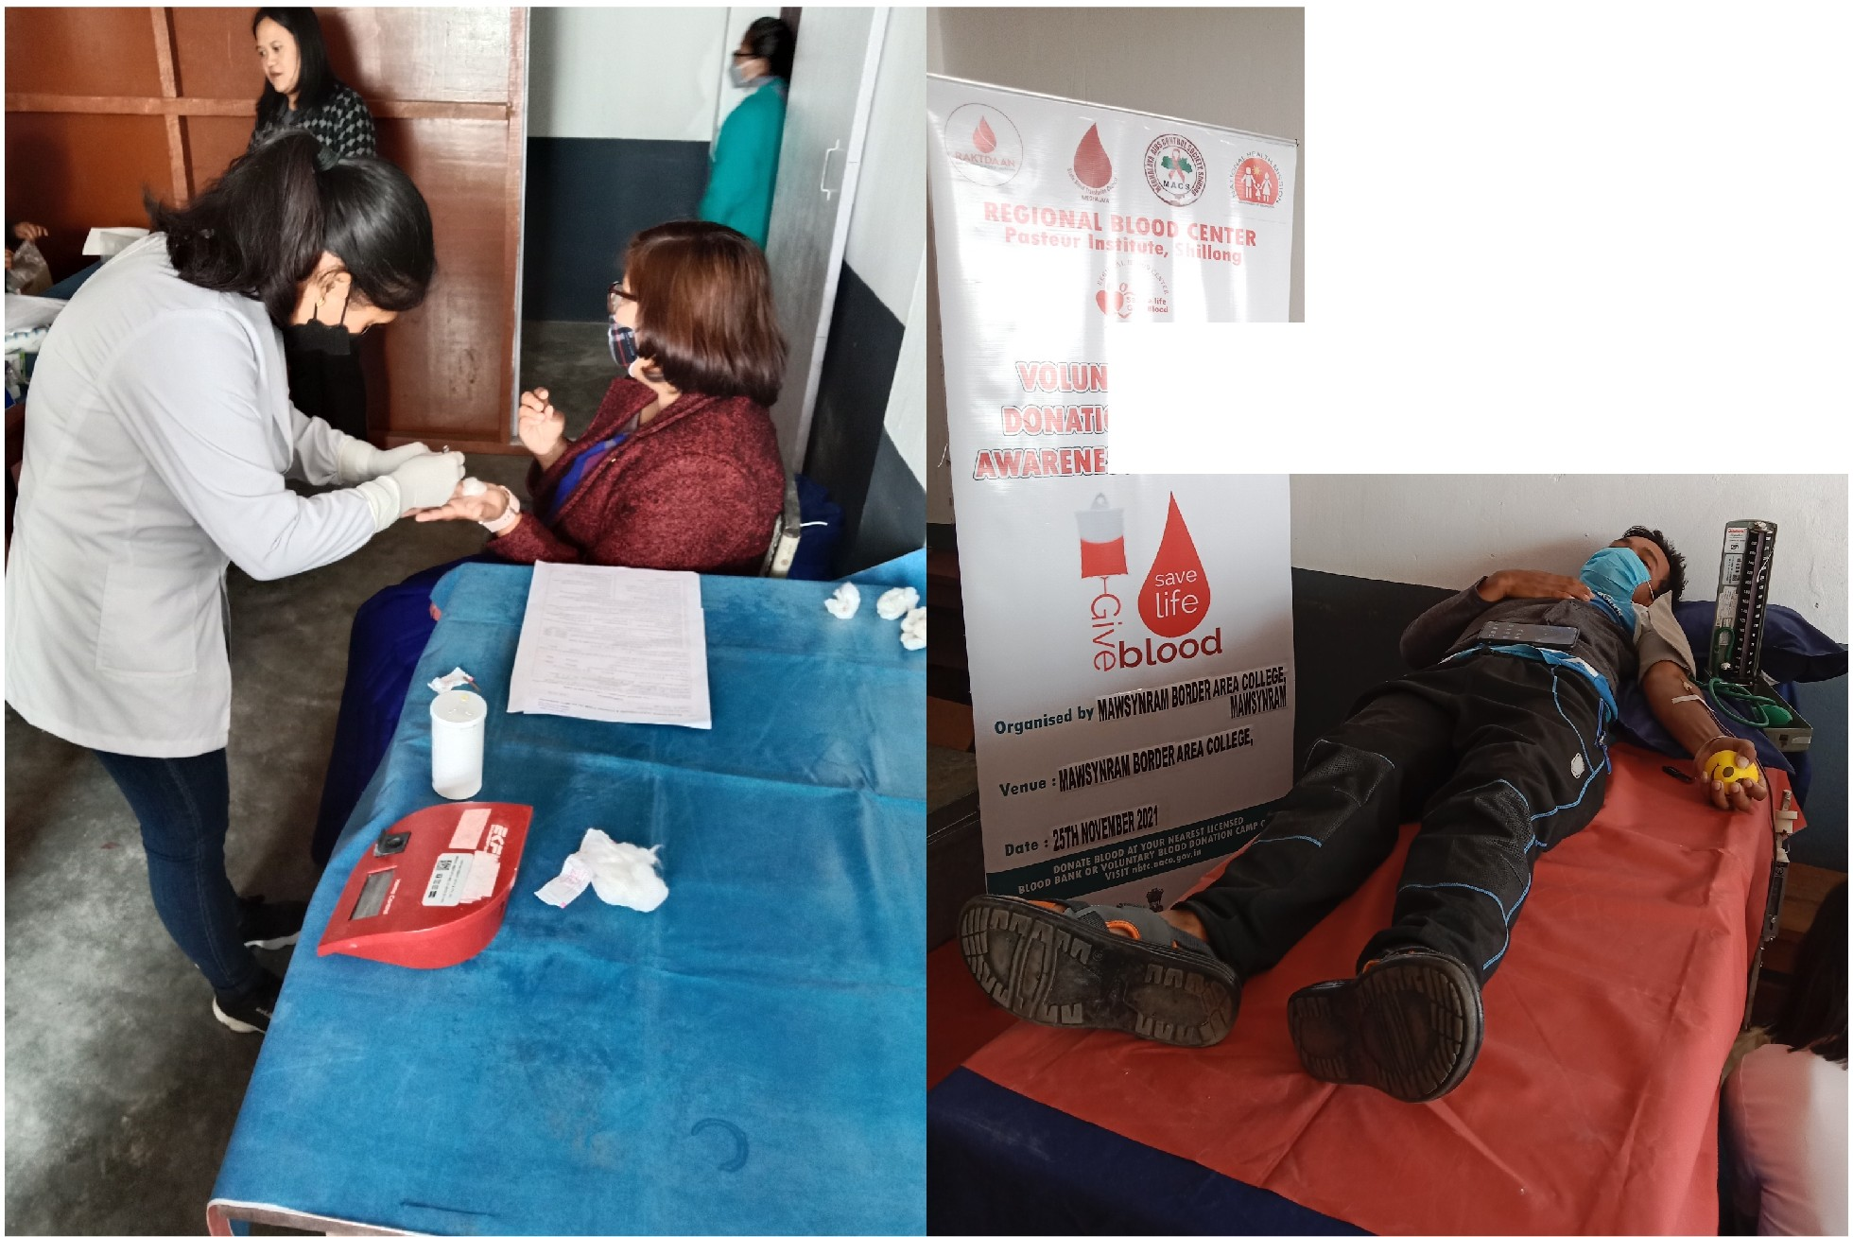
[ ]f ,l_ .
1 'L 'Pt J[M,
EI$Ji@JrJOO,OO

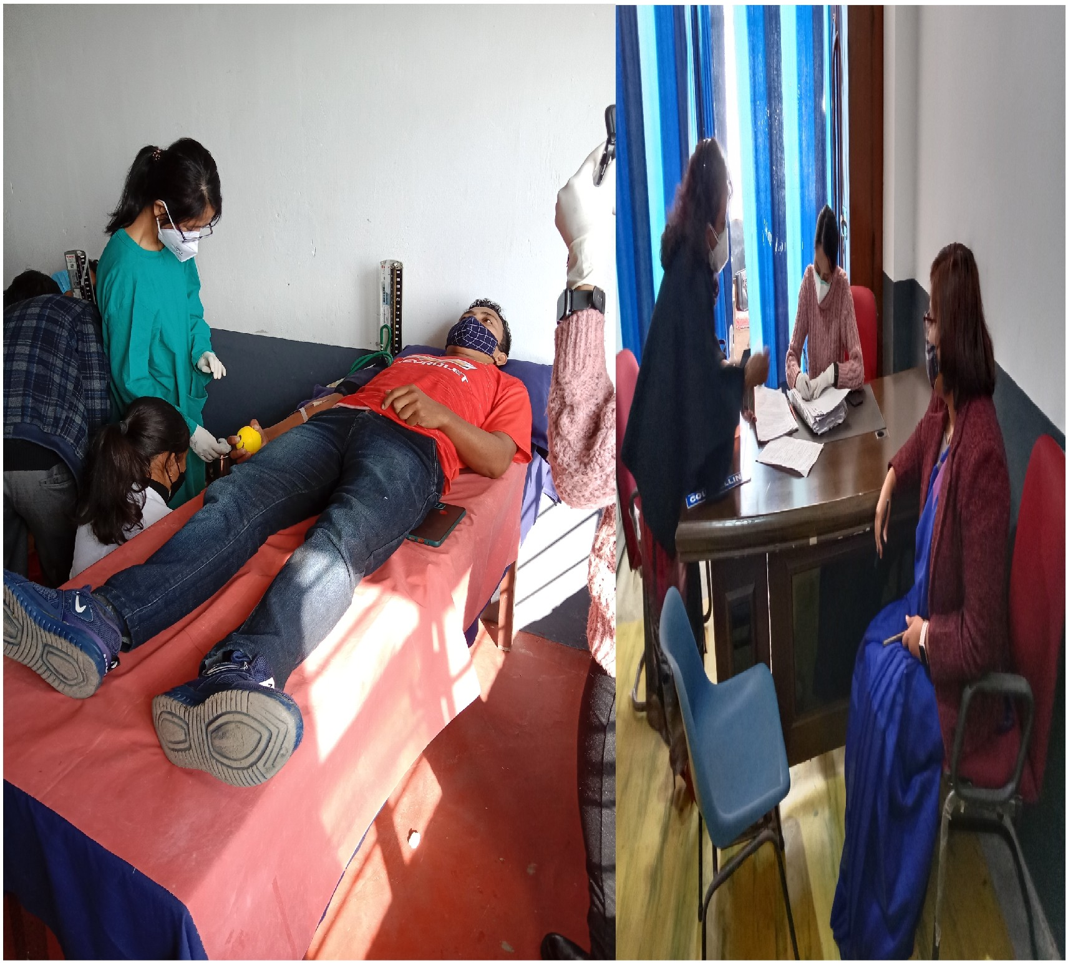

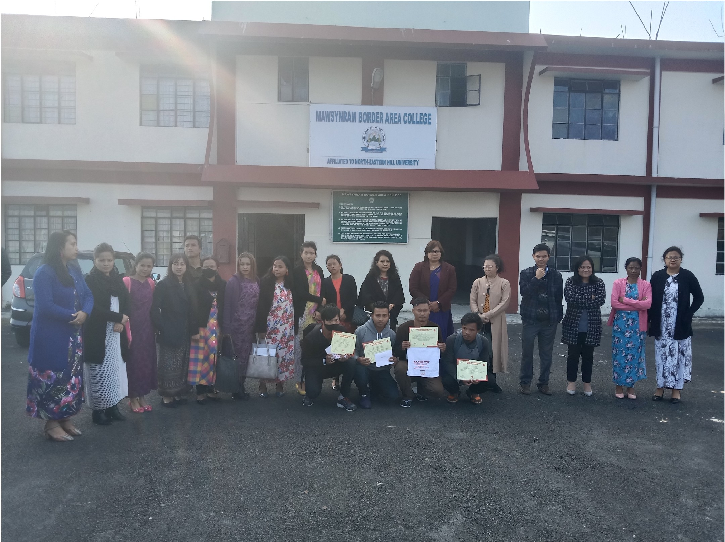

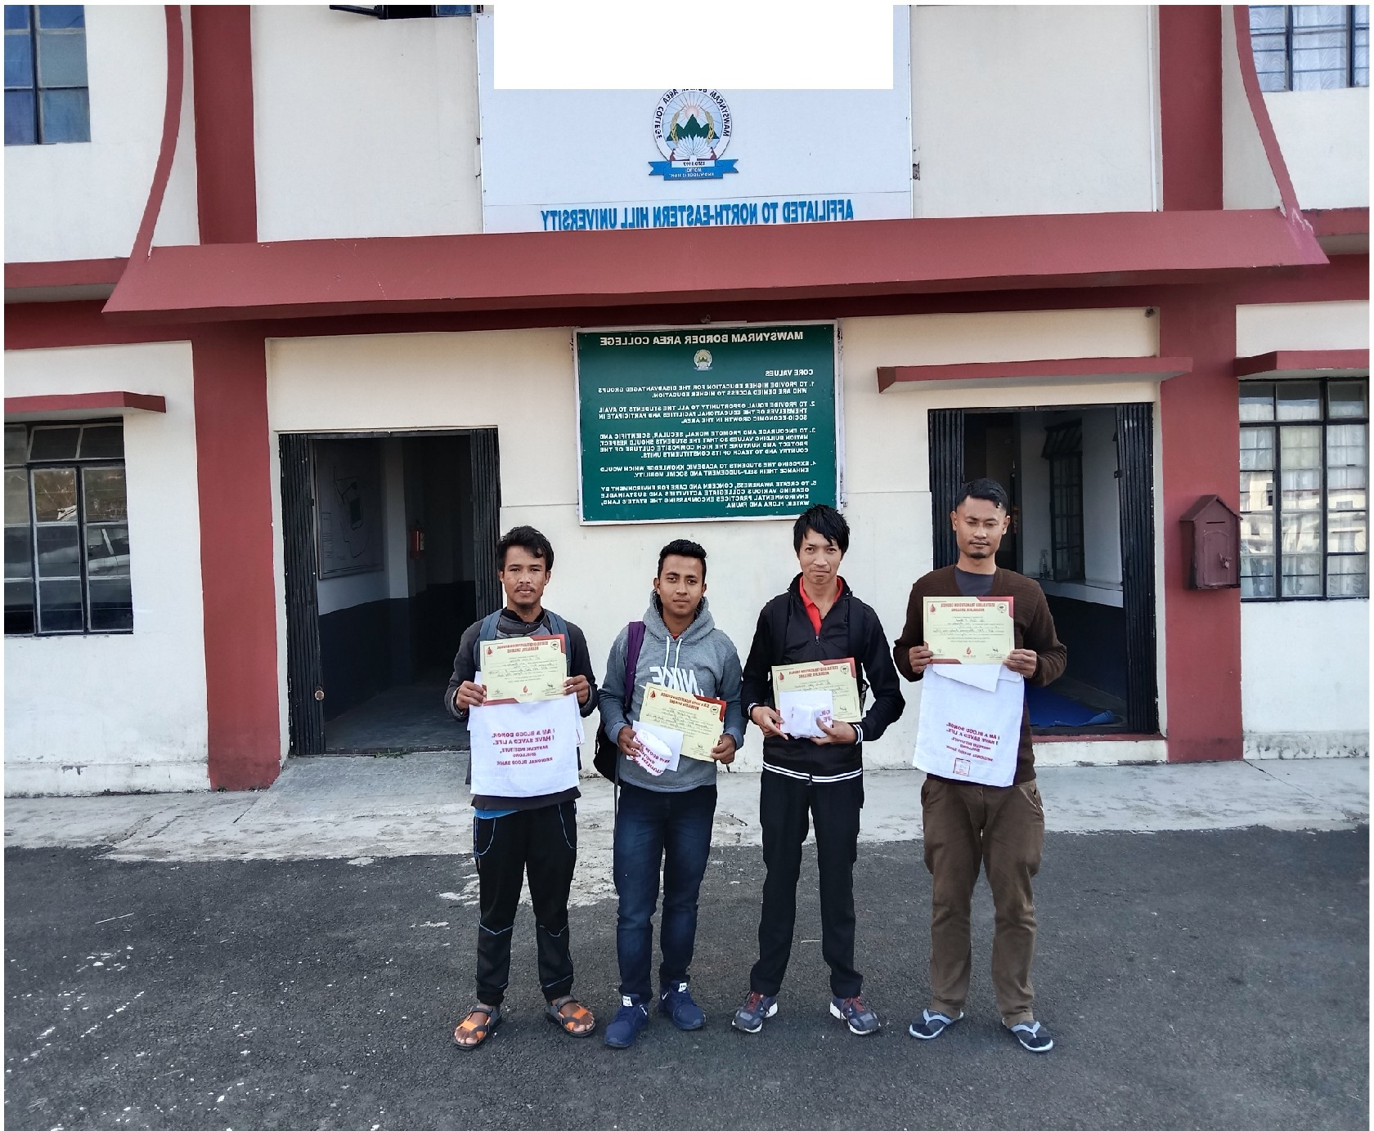
303JJ0 A3RAR3QR08 MARMY2WAM

